What if we told you there was a way to both lower property taxes for homeowners and spur more redevelopment of vacant lots in Cook County? A vacant land tax would both shift some property taxes to owners who aren't developing vacant lots and encourage their redevelopment. In 2008, the Cook County Board passed Ordinance No. 08-O-51, a tax break that lowered the assessment level for vacant land from 22% to 10%. The world was dealing with an economic crisis, and Cook County Assessor Joe Houlihan proposed a tax cut to prevent further foreclosures in the city and encourage redevelopment.
Nearly two decades later, however, this temporary measure meant to address a global crisis did not encourage development as intended. Taxing vacant land at lower rates rewards landowners for tearing down buildings and holding land for speculation. That leaves communities such as Englewood struggling with patchwork streets dotted with often poorly maintained properties. For example, the corner of 63rd and Halsted (6300 S Halsted St), steps away from the Halsted Green Line station, was historically a minor shopping plaza in Englewood. In 2012 its three-story building was home to three small businesses: a furniture store, a minimart, and a shoe store. According to Cook County property tax records, the owner paid $14,452 in property taxes for 2012, about $10,200 on the building and $4,300 on the land. The City issued an emergency permit to demolish the building in September 2014. The next year, the tax bill fell to $1,753, all of it on the land.
The land itself was worth the same after the demolition but the tax on the land went down 60 percent because of Cook County law. The Assessor valued it at about $95,700 both before and after the demolition. What changed was its classification. As commercial property, the land was assessed at 25% of its value; as vacant land, it was assessed at just 10%. So the owner's taxes didn’t only drop by the building’s share. The tax on the same land fell by 60%, from $4,438 to $1,753. In total, the bill dropped by about $15,000 a year, and that shortfall is picked up by every other taxpayer in the same taxing districts while the land sits empty. This is an unfair and bad policy.
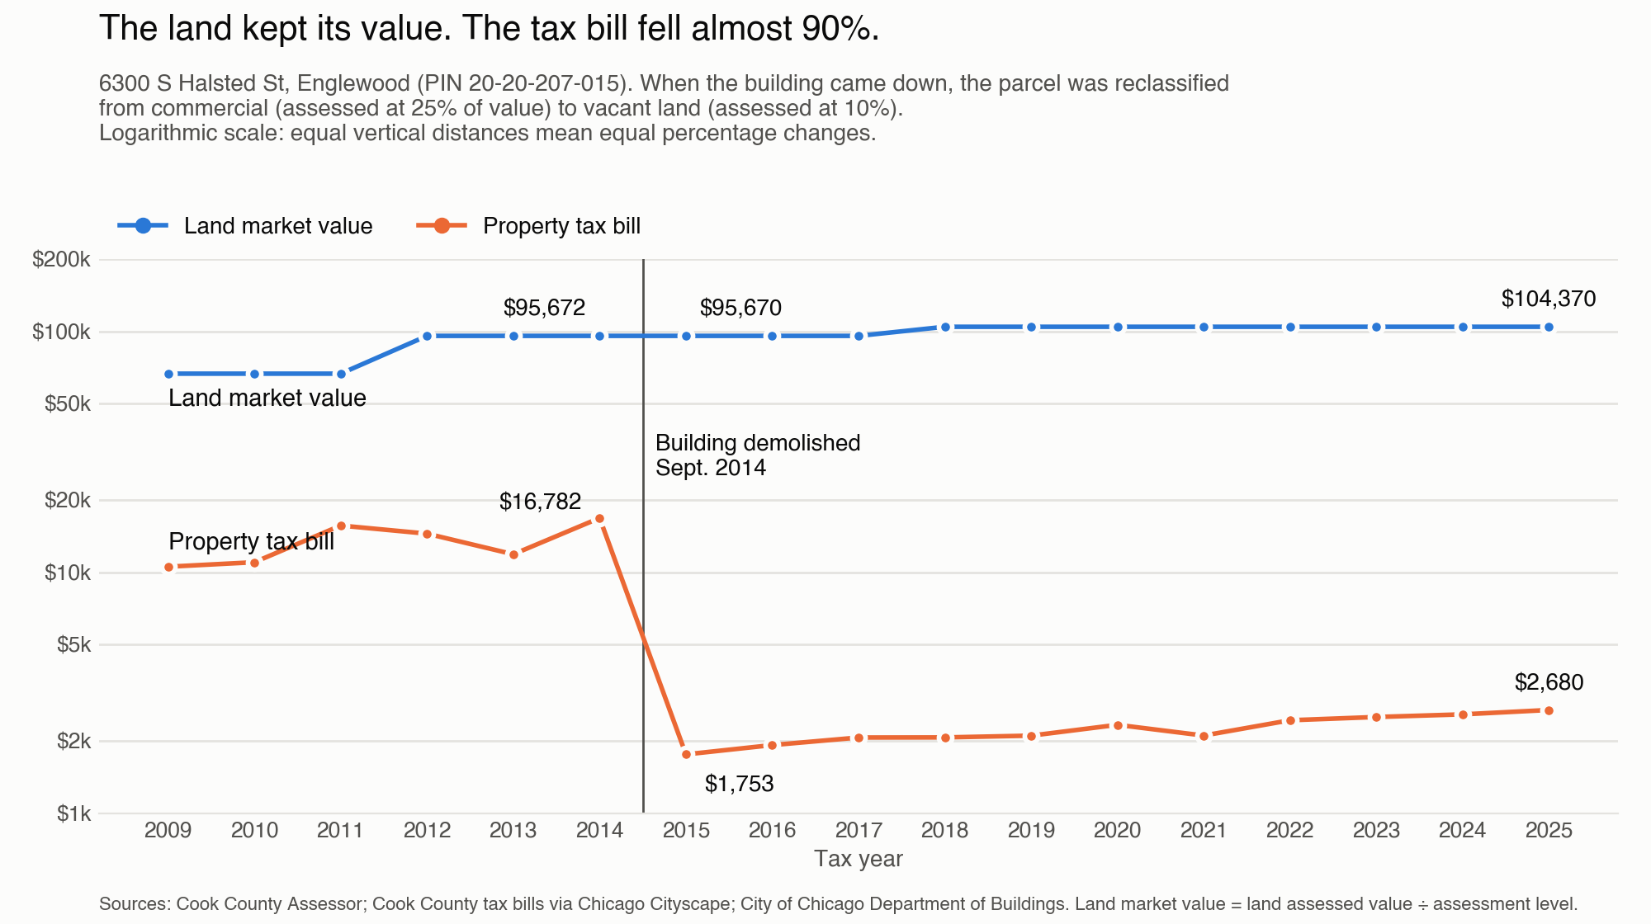

There are nearly 59,000 vacant land parcels in Cook County which qualify for this lower tax rate of 10%. We modeled the effect on tax bills when vacant land is taxed on 25% of its value rather than the 10% current rate (remember that less than two decades ago vacant lots were taxed on 22% of their value). The model proposes no other changes to existing tax rates. We found that increasing the tax rate from 10% to 25% would shift $183 million property taxes from mostly residential property owners to the vacant lot owners. Because vacant lots would account for a bigger portion of the tax levy pie, virtually every other property class is able to pay less.
Assuming that future property tax levies in Cook County, by all of the taxing bodies, would match the 2024 levy each year, the median vacant land parcel would pay $890 more, while the median owners of single family homes and large multi-family units pay $57 and $200 less respectively. It's probably not safe to assume levies would stay the same but it clearly shows a shift in who pays taxes when vacant lot owners are taxed at approximately what they used to be taxed at.
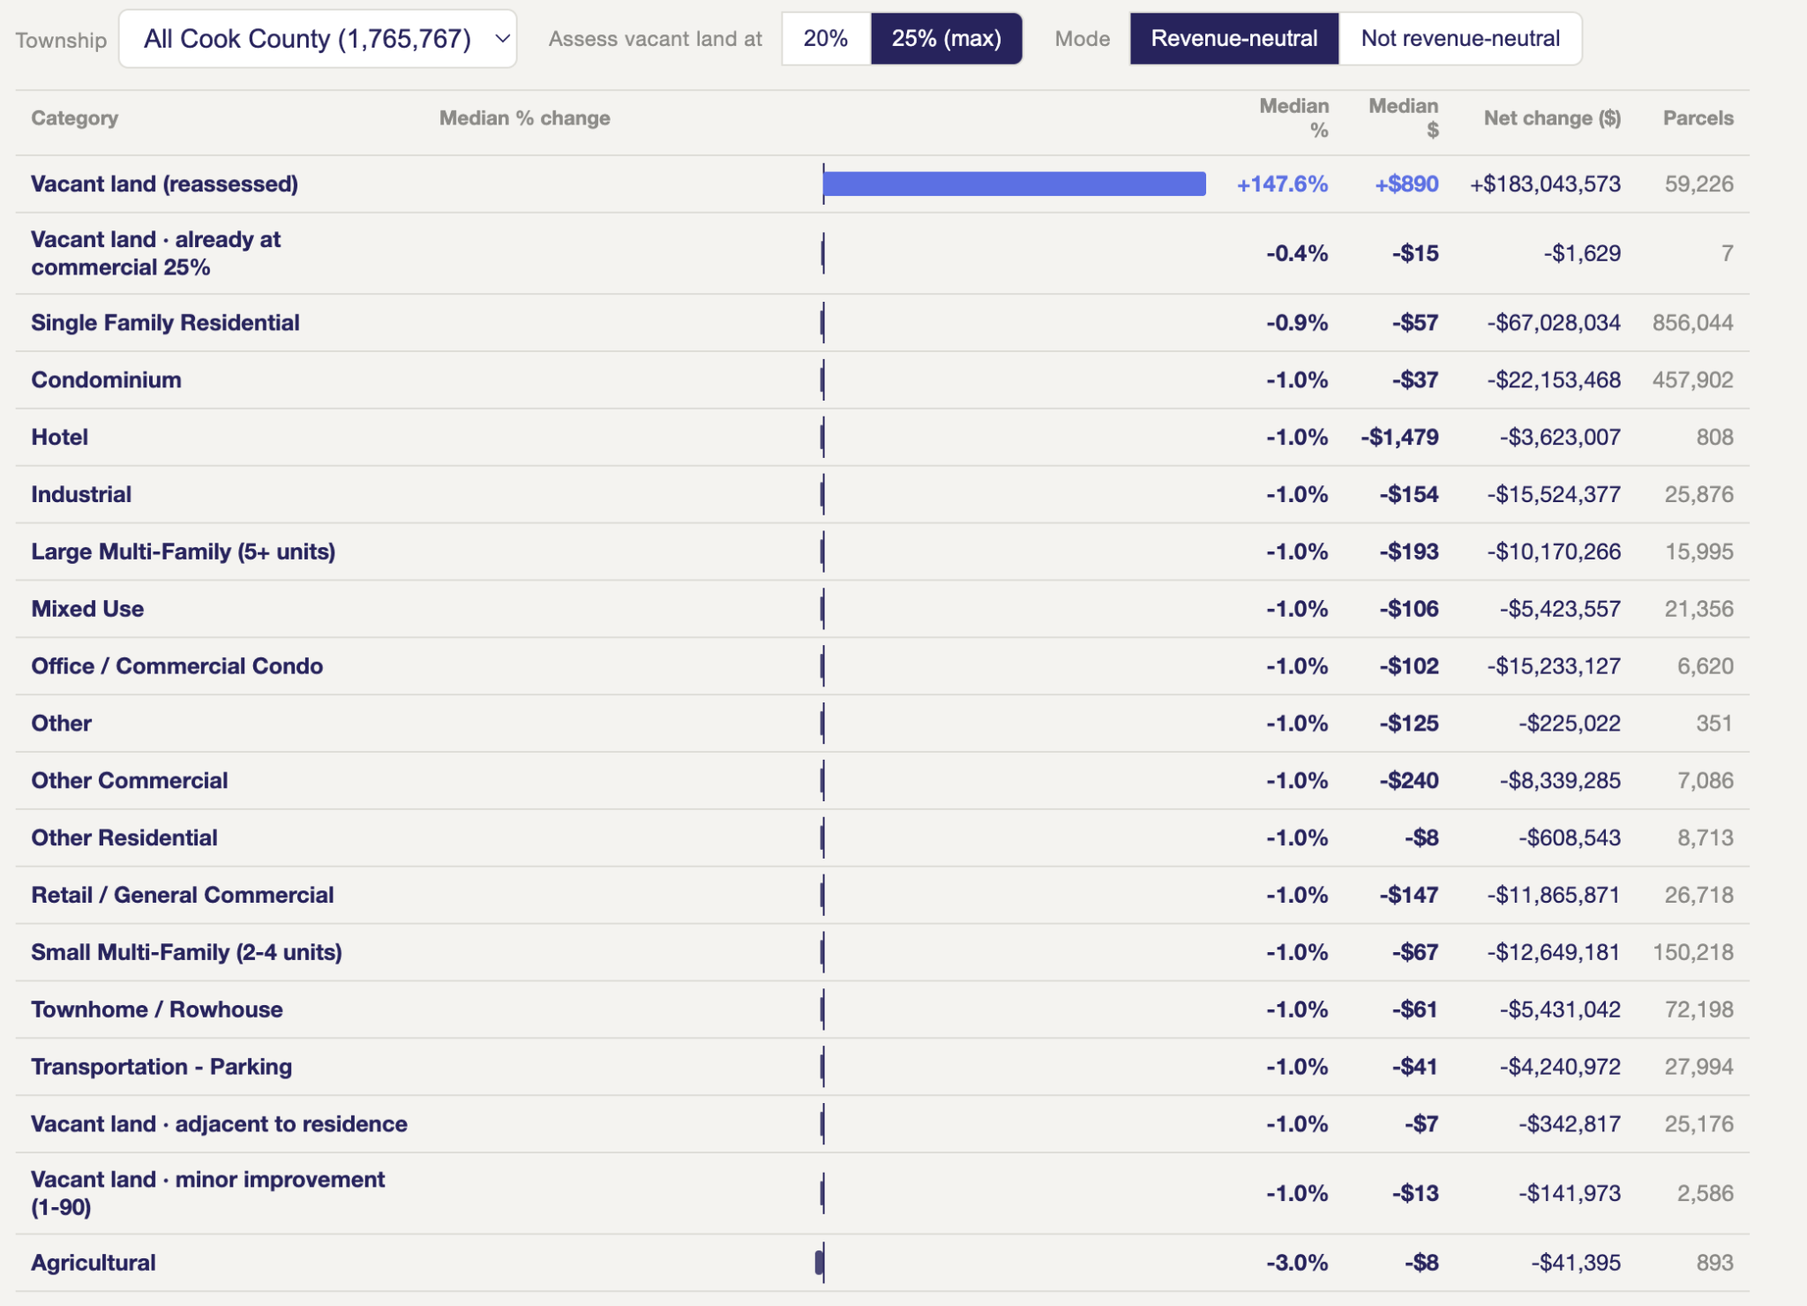

Our model doesn’t account for additional property tax revenue generated from new developments that are incentivized by the higher 25% tax rate. Between 2023 and 2024 there were 1,766 vacant lots in Cook County redeveloped, which added $224 million in assessed value the taxing bodies couldn't have taxed before 2024. Taxing bodies in Cook County were able to collect new revenue based on an additional 892% in market value, billing them an additional $54 million compared to the pre-developed vacant lot situation. In a hypothetical scenario where the total tax levy stayed the same between 2023 and 2024, that's $54 million that would have been given in relief to all other property tax payers. In reality, the total tax levy increased 4.7 percent from 2023 to 2024, a significantly lower figure than the 890 percent increase billed to the owners who redeveloped their vacant lots.

The total property tax billed in Cook County rose 4.7% in 2024, to $19.2 billion. That same year, about 1,770 formerly vacant lots that were built on saw their tax bills rise 882%, adding about $54 million to the tax base. New construction is exempt from the state's tax cap, so it is new revenue for local governments rather than a shift onto existing taxpayers. Imagine the extra property tax revenue we’d incur if we have a system designed to encourage development! With property taxes constantly rising, we need to turn over every stone to mitigate the increase, and increasing the assessment levels from 10% to 25% on vacant land can help us do that.

Even more important than alleviating tax burdens, however, is the benefit to communities that encourage more businesses. The available evidence in the United States shows that raising the tax on the land portion of property relative to the building portion of property reduces vacancies in buildings and spurs development. Indeed, when Pennsylvania cities adopted a system of taxing land at a higher rate than buildings, there was a statistically meaningful and immediate increase in the number of business establishments in municipalities that switched to a split-rate system. This was associated with a gain of 60 to 107 business establishments.

Cook County has a kind of split rate system, where taxes different based on property's classification. Properties in all other Illinois counties are assessed at 33% of their market value while properties in Cook County are assessed at either 10% (vacant land and residential), 20% (buildings owned by non-profit organizations and industrial properties granted an incentive), and 25% (shopping, retail, industrial, and office). The issue we're highlighting is that Cook County's current split rate ordinance has a preference for discounting the value of vacant land, even though vacant land is not valuable to Cook County.

Increasing the assessment level on vacant land is an idea that is starting to gain some steam. Last April, nearly 200 people attended the "Tax & The City" event, where a panel of experts discussed ways Illinois could spread our tax burden more equitably. The crowd included the usual urbanist nerds we see at these events, but also a fair share of normies. That's a sign that people are looking for new ways to slow our year-over-year tax increases and spur more development.
The interest isn't limited to Chicago. This spring, two states passed laws letting cities tax land at a higher rate than buildings, the first such laws in decades. In April, Virginia unanimously passed HB 282, which allows Charlottesville, Falls Church, Fredericksburg and Newport News to adopt a split-rate land value tax. Days later, Kentucky's legislature overrode the governor's veto of HB 607, which lets Louisville raise taxes on vacant lots and surface parking in its urban core. Similar bills are pending in Maryland, Minnesota, New York, Colorado, Maine, New Hampshire, Ohio and Washington, D.C. Detroit's plan to cut homeowners' taxes by shifting the burden to land cleared a Michigan House committee but has stalled on the House floor.
Illinois has been quieter. A state Senate bill this year (SB 3938) would let any taxing district adopt a land value tax, but it never got a hearing. Cook County doesn't need to wait for Springfield, though. The Illinois Constitution already lets the county assess different classes of property at different levels, as long as the highest is no more than 2.5 times the lowest. Raising vacant land from 10% to 25% fits within that limit and needs only a vote of the Cook County Board of Commissioners.

You can see how tax bills on vacant properties would change using our interactive map here, developed by the Progress and Poverty Institute.
We counted properties that were classified as "1-00" in 2023 and classified as a 2, 3, or 5 classification group in 2025. Groups 2 and 3 are assessed based on 10% of their market value and group 5 is assessed based on 25% of its market value. The property in the Englewood example above was classified as 5-92 (Two-or-three story building containing part of all retail and/or commercial space).
We also looked into instituting a land value tax (LVT) like the Pennsylvania cities had adopted, and which Finland has. This would involve - Moving from our current system: - (Improvement Value + Land Value) x Tax Rate = Tax Bill - To a new split-rate system: - (Improvement Value x Lower Tax Rate) + (Land Value x Higher Tax Rate) = Tax Bill However, the Illinois constitution requires that the highest assessment level is no more than 2.5x greater than the lowest assessment level. This means that we could set the taxes on land at only 25% and encourage more buildings by taxing them at 10%. If we instituted LVT with this constraint, the effect is that property taxes would decrease in the Loop and increase almost everywhere else in Cook County, including most homeowners. The building to land ratio is so much greater in the Loop that with this 2.5 constraint, the tax burden would need to shift elsewhere. So effectively, pure LVT would decrease the tax burden on commercial properties in the Loop and increase it on homeowners. Overturning this 2.5x rule would require an Illinois Constitutional amendment. This constitutional restraint is why we make the case for a tax increase on vacant land in this piece instead of instituting a system of land-value taxes.
On the November ballot, there is a public question “Should the City of Chicago require owners of long-term vacant or undeveloped commercial or investment properties to pay an annual charge that would support Chicago Public Schools”. Increasing the tax rate and allocating the new revenue to CPS instead of homeowners would probably not result in the broad property tax alleviation for residential property owners.

